**DAILY ONLINE ACTIVITIES SUMMARY**

|  |  |  |  |  |  |  |  |  |
| --- | --- | --- | --- | --- | --- | --- | --- | --- |
| **Date:** | **03-06-2020** | | | | | **Name:** | **Dhanush Shetty** | |
| **Sem & Sec** | **8 A** | | | | | **USN:** | **4AL16CS032** | |
| **Online Test Summary** | | | | | | | | |
| **Subject** | | **-** | | | | | | |
| **Max. Marks** | | **-** | | **Score** | | | **-** | |
| **Certification Course Summary** | | | | | | | | |
| **Course** | **Introduction to CodeBuild.** | | | | | | | |
| **Certificate Provider** | | | **AWS** | | **Duration** | | | **10 mins** |
| **Coding Challenges** | | | | | | | | |
| **Problem Statement:**   1. **Python program to find H.C.F of two numbers.** | | | | | | | | |
| **Status: Solved** | | | | | | | | |
| **Uploaded the report in Github** | | | | | **Yes** | | | |
| **If yes Repository name** | | | | | **Dhanushshett/online_c_coding_repository** | | | |
| **Uploaded the report in slack** | | | | | **Yes** | | | |

Online Test Details: (Attach the snapshot and briefly write the report for the same)

NOT CONDUCTED

Certification Course Details: (Attach the snapshot and briefly write the report for the same)

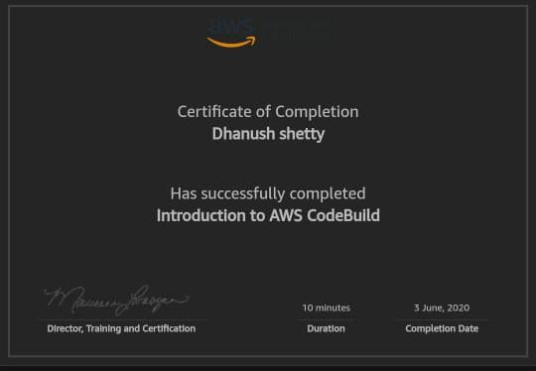

Coding Challenges Details: (Attach the snapshot and briefly write the report for the same)

**PROGRAM 1 .**

**// Python program to find H.C.F of two numbers.**

**def compute_hcf(x, y):**

**if x > y:**

**smaller = y**

**else:**

**smaller = x**

**for i in range(1, smaller+1):**

**if((x % i == 0) and (y % i == 0)):**

**hcf = i**

**return hcf**

**num1 = 54**

**num2 = 24**

**print("The H.C.F. is", compute_hcf(num1, num2))**